**Industrial Internship Report on**

**”Python project”**

**Prepared by**

**Prateek Lewis**

|  |
| --- |
| *Executive Summary* |
| I am pleased to announce the successful completion of my 6-week Python internship with Upskill and UTC. Throughout this internship, I had the opportunity to delve into the world of data science with Python, covering a wide range of topics and gaining a deep understanding of the subject.  Over the course of the internship, I delved into various aspects of data science, including data manipulation, analysis, and visualization. I learned about key Python libraries such as NumPy, Pandas, and Matplotlib, and how they can be utilized for data processing and exploration. Additionally, I gained valuable insights into statistical concepts and machine learning algorithms.  My project was Password Manager. Password manager project is a secure and convenient solution for managing and storing passwords. With the increasing number of online accounts and the need for strong, unique passwords, it has become essential to have a reliable system in place to store and access these credentials.  This internship gave me a very good opportunity to get exposure to Industrial problems and  design/implement solution for that. It was an overall great experience to have this internship. |

**TABLE OF CONTENTS**

1 Preface 2

2 Introduction 5

2.1 About UniConverge Technologies Pvt Ltd 6

i. UCT IoT Platform 6

2.2 About upskill Campus (USC) 10

2.3 The IoT Academy 11

2.4 Objectives of this Internship program 12

2.5 Glossary 12

3 Problem Statement 12

3.1 Code submission (Github link) https://github.com/PrateekLewis/URL_shortner 13

3.2 Report submission (Github link) : Report is in the same repository as the project. 13

Proposed Design/ Model 14

4 Performance Test 15

4.1 Performance Outcome 15

5 My learnings 17

6 Future work scope 18

# Preface

Over the course of the 6-week internship, I have gained valuable experience and knowledge in the field of Python programming. Each week presented new challenges and opportunities for learning, allowing me to develop my skills and expand my understanding of various concepts and technologies.

During the internship, I covered a wide range of topics including the basics of Python, embedded systems, core Java, data science, cyber security, industry 4.0 skills, Numpy, Pandas, and more. Through hands-on projects and practical assignments, I had the opportunity to apply my learning and enhance my problem-solving abilities.

The internship also provided exposure to real-world scenarios and industry practices, giving me a deeper understanding of how Python is used in different domains. By working on problem statements and implementing solutions, I gained practical experience and improved my coding proficiency.

Furthermore, the internship helped me realize the importance of relevant internships in career development. It provided a platform to bridge the gap between theoretical knowledge and practical application. By working on industry-relevant projects and learning from experienced professionals, I gained insights into the demands and expectations of the professional world.

Overall, the 6-week internship has been a valuable experience that has enhanced my technical skills, expanded my knowledge base, and prepared me for future career opportunities. It has reinforced the significance of hands-on experience and continuous learning in the field of technology. I am grateful for the opportunity and look forward to applying my newfound skills and knowledge in my future endeavors.

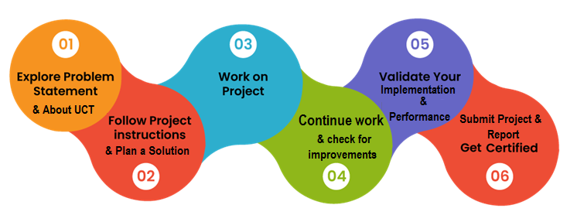

During the course of my 6-week internship, I have experienced significant personal and professional growth. I have gained a deep understanding of data science with Python and have developed a strong foundation in various concepts and techniques. The hands-on projects and practical assignments have allowed me to apply my knowledge and sharpen my problem-solving skills. Overall, this internship has been a transformative learning experience that has equipped me with valuable skills for my future career in data science.

I would like to express my heartfelt gratitude to all those who have supported me throughout this internship journey. Firstly, I would like to thank my mentors for their guidance, expertise, and constant encouragement. Their insights and feedback have been invaluable in shaping my understanding and enhancing my skills. I am truly grateful for their mentorship.

I would also like to thank the entire team at Upskill and UTC for creating a conducive learning environment. The interactive sessions, engaging discussions, and collaborative projects have enhanced my learning experience. I am thankful for the opportunity to learn from and collaborate with talented individuals.

To my juniors and peers who may be considering similar internships or pursuing a career in data science, I would like to share a few words of advice. Embrace every learning opportunity that comes your way and approach each task with curiosity and enthusiasm. Be proactive in seeking guidance and support from mentors and peers. Remember that learning is a continuous process, and it's essential to stay updated with the latest advancements in the field. Finally, believe in yourself and your abilities. With dedication and perseverance, you can achieve great things in your data science journey.

# Introduction

## About UniConverge Technologies Pvt Ltd

A company established in 2013 and working in Digital Transformation domain and providing Industrial solutions with prime focus on sustainability and RoI.

For developing its products and solutions it is leveraging various**Cutting Edge Technologies e.g. Internet of Things (IoT), Cyber Security, Cloud computing (AWS, Azure), Machine Learning, Communication Technologies (4G/5G/LoRaWAN), Java Full Stack, Python, Front end**etc.

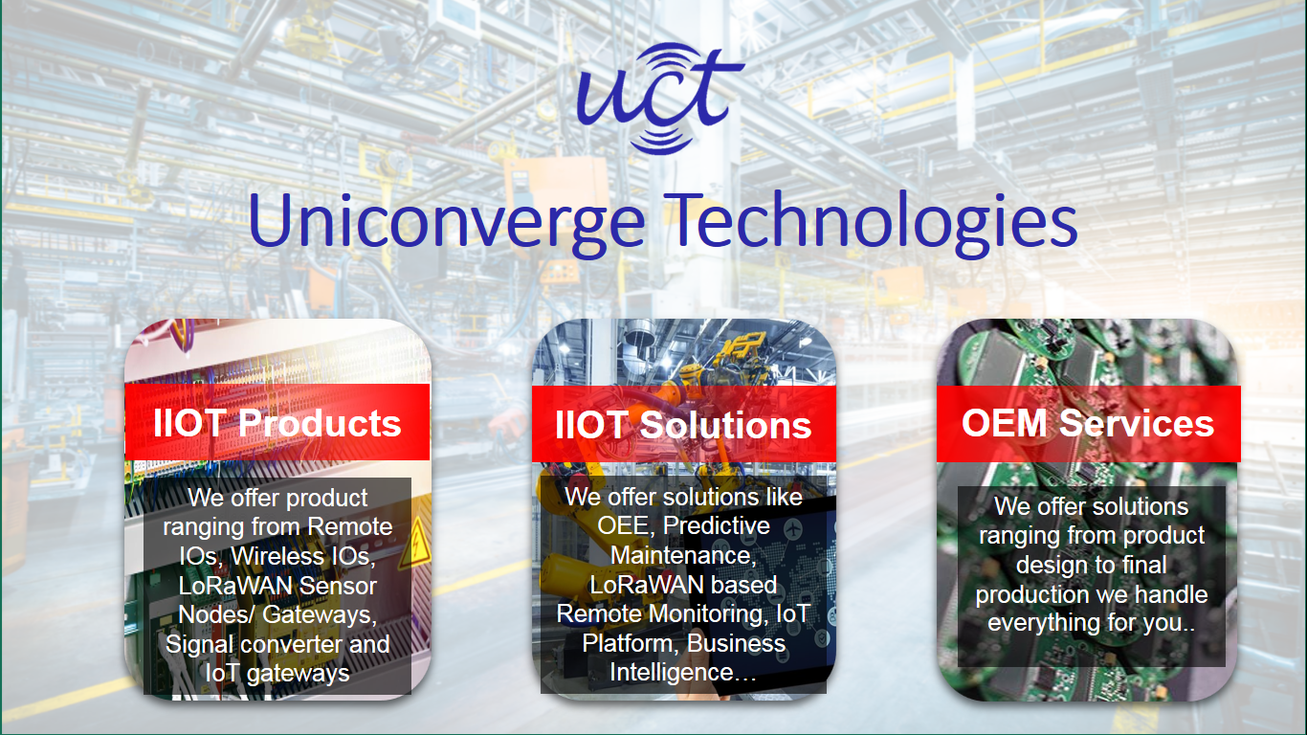

1. UCT IoT Platform **(****)**

**UCT Insight** is an IOT platform designed for quick deployment of IOT applications on the same time providing valuable “insight” for your process/business. It has been built in Java for backend and ReactJS for Front end. It has support for MySQL and various NoSql Databases.

* It enables device connectivity via industry standard IoT protocols - MQTT, CoAP, HTTP, Modbus TCP, OPC UA
* It supports both cloud and on-premises deployments.

It has features to  
• Build Your own dashboard  
• Analytics and Reporting  
• Alert and Notification  
• Integration with third party application(Power BI, SAP, ERP)  
• Rule Engine

 

1. **Smart Factory Platform (****)**

Factory watch is a platform for smart factory needs.

It provides Users/ Factory

* with a scalable solution for their Production and asset monitoring
* OEE and predictive maintenance solution scaling up to digital twin for your assets.
* to unleased the true potential of the data that their machines are generating and helps to identify the KPIs and also improve them.
* A modular architecture that allows users to choose the service that they what to start and then can scale to more complex solutions as per their demands.

Its unique SaaS model helps users to save time, cost and money.

 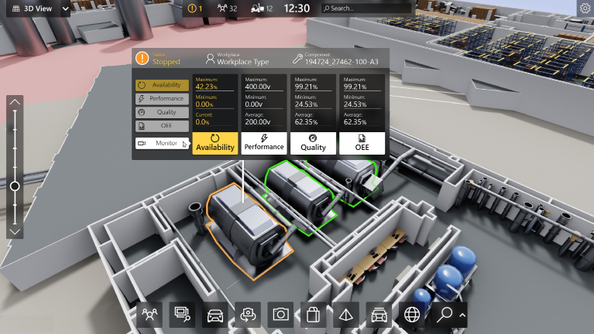

1. 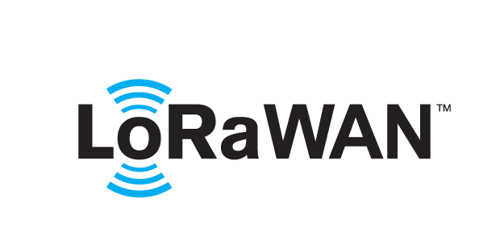 based Solution

UCT is one of the early adopters of LoRAWAN teschnology and providing solution in Agritech, Smart cities, Industrial Monitoring, Smart Street Light, Smart Water/ Gas/ Electricity metering solutions etc.

1. Predictive Maintenance

UCT is providing Industrial Machine health monitoring and Predictive maintenance solution leveraging Embedded system, Industrial IoT and Machine Learning Technologies by finding Remaining useful life time of various Machines used in production process.



## About upskill Campus (USC)

upskill Campus along with The IoT Academy and in association with Uniconverge technologies has facilitated the smooth execution of the complete internship process.

USC is a career development platform that delivers **personalized executive coaching** in a more affordable, scalable and measurable way.



Seeing need of upskilling in self paced manner along-with additional support services e.g. Internship, projects, interaction with Industry experts, Career growth Services

<https://www.upskillcampus.com/>

upSkill Campus aiming to upskill 1 million learners in next 5 year

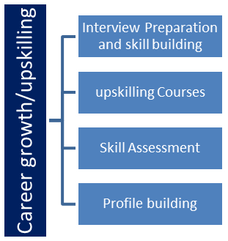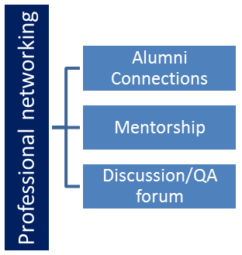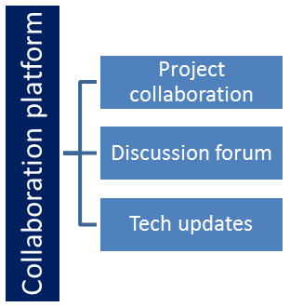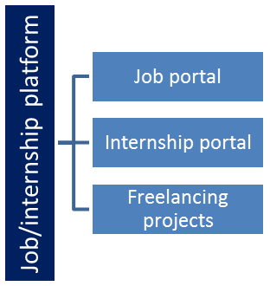

## The IoT Academy

The IoT academy is EdTech Division of UCT that is running long executive certification programs in collaboration with EICT Academy, IITK, IITR and IITG in multiple domains.

## Objectives of this Internship program

The objective for this internship program was to

 ☛ get practical experience of working in the industry.

 ☛ to solve real world problems.

 ☛ to have improved job prospects.

 ☛ to have Improved understanding of our field and its applications.

 ☛ to have Personal growth like better communication and problem solving.

## Glossary

|  |  |
| --- | --- |
| Terms | Acronym |
| Data science | A multidisciplinary field that uses scientific methods, processes, algorithms, and systems to extract insights and knowledge from structured and unstructured data. |
| Machine learning | A subset of artificial intelligence that enables systems to learn and make predictions or take actions without being explicitly programmed. It focuses on the development of algorithms and models that allow computers to learn and improve from experience. |
| Data Visualization | The graphical representation of data and information using visual elements such as charts, graphs, and maps. |
| Natural language processing (NLP) | A field of study that focuses on the interaction between computers and human language. It involves the analysis and understanding of human language, enabling machines to process and interpret text or speech data. |
|  |  |

# Problem Statement

The problem statement for this project is to develop a link shortening tool that allows users to convert long URLs into shorter, more manageable links. The aim is to provide a convenient and efficient solution for users who need to share URLs that are too long, complex, or difficult to remember. The project should offer a reliable and scalable system that generates shortened links quickly and accurately, while also ensuring the security and integrity of the generated links. The tool should be user-friendly, allowing users to input their long URLs and receive shortened links that are easy to share and track. The project should address the challenges of handling a large volume of link conversions, ensuring the performance and scalability of the system.

## Code submission (Github link) <https://github.com/PrateekLewis/URL_shortner>

## Report submission (Github link) : Report is in the same repository as the project.

# Proposed Design/ Model

The provided code implements a function that utilizes the Cutt.ly API to shorten a given link. The function takes a full link and a name for the shortened link as input. It sends a request to the Cutt.ly API with the provided information and retrieves the shortened link generated by the API.

The function extracts the title and short link from the API response and prints them as output. If there is an error during the API request, it prints the error status instead.

Overall, the model of the project involves integrating with the Cutt.ly API to provide link shortening functionality. It demonstrates the usage of the requests library to interact with an external API and retrieve data. The function can be further extended or integrated into a larger application that requires link shortening capabilities.

# Performance Test

In terms of performance, the code provided seems to be straightforward and efficient. It utilizes the requests library to send an HTTP request to the Cutt.ly API and retrieve the shortened link. The API call is made synchronously, so the code waits for the response before proceeding.

The performance of the code will primarily depend on the speed and reliability of the network connection, as it relies on making a request to an external API. The response time will be influenced by factors such as network latency and the API server's responsiveness.

It's worth noting that the performance can be impacted if there are issues with the API service itself, such as high server load or maintenance. In such cases, the response time may be slower or the API request may fail.

Overall, as long as the network connection and the Cutt.ly API are functioning optimally, the provided code should perform well and provide quick results for link shortening. However, it's always a good practice to handle potential exceptions or errors that may occur during the API request to ensure a robust and reliable performance.

## Performance Outcome

The performance outcome of the provided code depends on various factors such as network connectivity, the responsiveness of the Cutt.ly API, and the speed of the server that hosts the API. Here are a few potential performance outcomes:

* Fast Response: If the network connection is stable and the API server is responsive, the code should provide a quick response with the shortened link and its associated title. This ensures a seamless user experience and efficient link shortening process.
* Delayed Response: If there are network issues or the API server is experiencing high traffic, the response time may be slower. This can result in a delay in obtaining the shortened link and its title. In such cases, the code may take longer to execute, leading to a potential impact on user experience.
* API Errors: The Cutt.ly API may occasionally encounter errors or undergo maintenance, resulting in failed API requests or error statuses. In such situations, the code will handle the error and display an appropriate message. It's essential to handle these cases gracefully and provide clear error messages to the user.
* 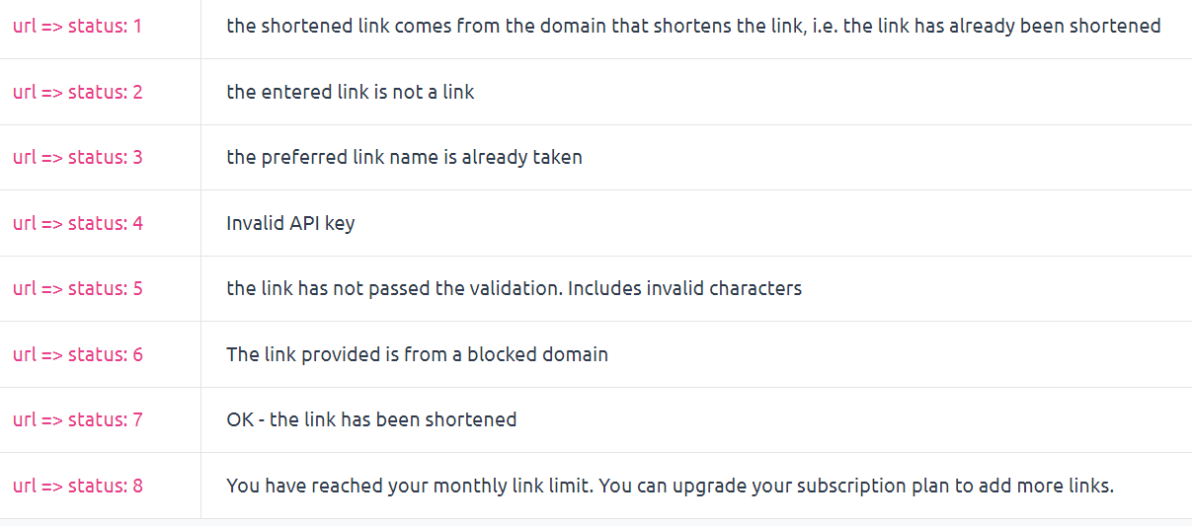

To ensure optimal performance, it's important to have a stable and reliable network connection. Additionally, regularly monitoring the performance of the API service and handling potential exceptions or errors will contribute to a smoother user experience.

# My learnings

Throughout this project, I have gained valuable learnings that have contributed to my personal and professional growth. Here are some of the key learnings I have acquired:

* Technical Skills: Working on this project has allowed me to deepen my technical skills in Python programming, API integration, and web development. I have gained hands-on experience in using libraries like requests and applying them to practical tasks such as link shortening. This has expanded my knowledge and proficiency in coding and software development.
* Problem-Solving and Critical Thinking: This project has presented me with various challenges that required problem-solving and critical thinking skills. I have learned to approach problems systematically, break them down into smaller parts, and analyze potential solutions. Through trial and error, I have developed the ability to think creatively and find innovative solutions to complex problems.
* Attention to Detail: The project has emphasized the importance of paying attention to detail in coding and project implementation. I have learned to carefully review my code, identify potential errors or bugs, and ensure the accuracy and efficiency of my solutions. This attention to detail has enhanced the overall quality of my work.

# Future work scope

The project has a promising future scope with several potential areas of expansion and enhancement. Here are some possible avenues for future development:

* User Interface Enhancement: The project's current focus is primarily on the backend functionality of link shortening. To enhance the user experience, the project can be extended to include a user interface where users can input their links and receive shortened links directly through a web or mobile application. This would involve designing an intuitive and user-friendly interface to make the link shortening process more accessible and convenient.
* Analytics and Tracking: Adding analytics and tracking capabilities can provide valuable insights into link usage and user behavior. By integrating tools like Google Analytics, the project can track metrics such as link clicks, user engagement, and conversion rates. These insights can help users analyze the performance of their shortened links and make data-driven decisions for marketing campaigns or website optimization.
* Link Customization and Personalization: Currently, the project generates short links with default names. Adding features to allow users to customize the generated links by choosing their preferred names or adding tags can enhance personalization. This customization feature can improve link branding, make links more memorable, and align them with specific marketing or branding strategies.